**Experiment No:** 04

**Experiment Name:** Thread programming in linux.

**Aim and Objectives:** According to this report we will focus on how a thread is created and identified. We will also present a working C program example that will explain how to do basic threaded programming.

**Source Code:**

#include<stdio.h>

#include<string.h>

#include<pthread.h>

#include<stdlib.h>

#include<unistd.h>

pthread_t tid[2];

void* doSomeThing(void *arg)

{

unsigned long i = 0;

pthread_t id = pthread_self();

if(pthread_equal(id,tid[0]))

{

printf("\n First thread processing\n");

}

else

{

printf("\n Second thread processing\n");

}

for(i=0; i<(0xFFFFFFFF);i++);

return NULL;

}

int main(void)

{

int i = 0;

int err;

while(i < 2)

{

err = pthread_create(&(tid[i]), NULL, &doSomeThing, NULL);

if (err != 0)

printf("\ncan't create thread :[%s]", strerror(err));

else

printf("\n Thread created successfully\n");

i++;

}

sleep(5);

return 0;

}

**Output :**

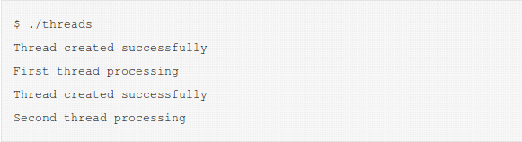

**Conclusion:**

In this lab experiment, we have learnt about thread programming in Linux using C language. We also learnt about creating a thread and working behavior of thread in c language.

.